|  |  |  |
| --- | --- | --- |
| **DCHCMetropoliD18bR05aP01ZL-Taylor5a** | **DCHC MPO**  **GIS/Database/Web** | **Date: 09/02/2021** |
| **User Manual Number: 3** |

**Adding a Map to an ArcGIS Online Dashboard**

1. Add the map to ArcGIS Online via ArcMap
   1. Sign in to your ArcGIS Online account within ArcMap
   2. Share the map as a Service
   3. Update the Summary, Description, and add Tags
   4. In the dialogue box click Analyze and correct any issues with the layer
   5. Publish the layer

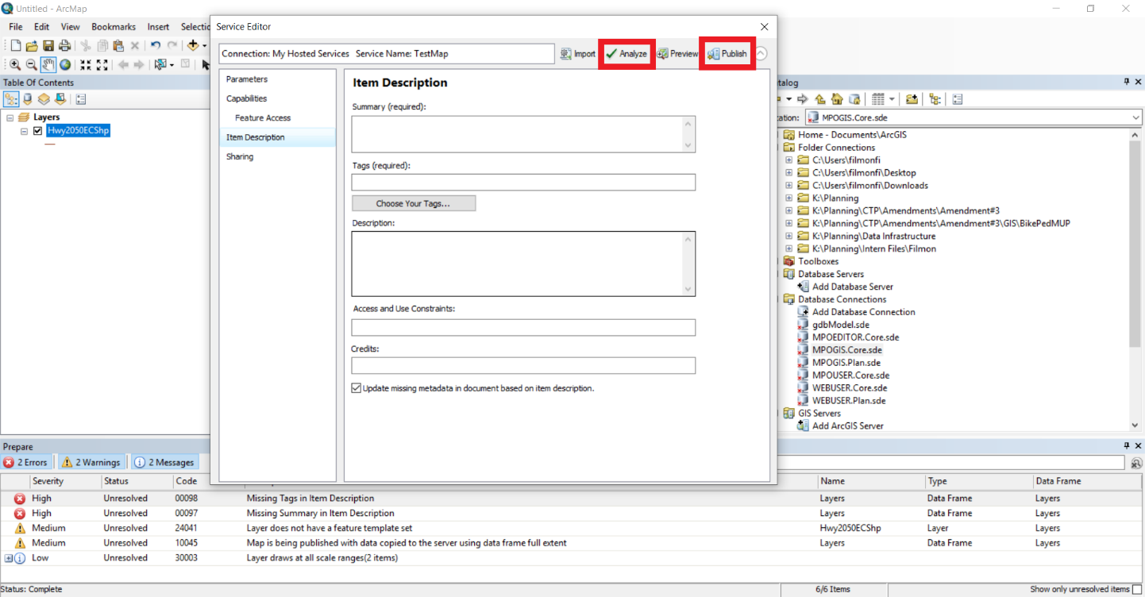

1. In ArcGIS Online go to My Content and open the Hosted Feature Layer that was just published.
2. Open the layer and Save As to create a Web Map
3. GO back to My Content and open the Web Map. The Web Map is where the analysis will be done and will be what displays in the Dashboard. Below are some examples of analyses that are included within ArcGIS Online
   1. Types (Unique Symbols)
   2. Counts and Amounts (color)
   3. Counts and Amounts (size)
   4. Heat Map
   5. Location (Single Symbol)
4. In My Content under Create App select the Dashboard option

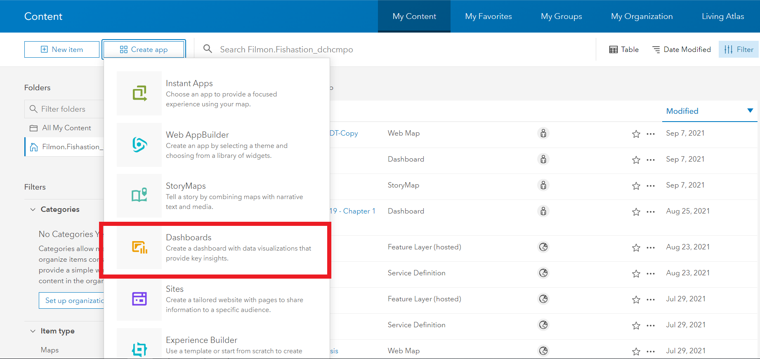

1. Fill in relevant Title, Tags, and Summary
2. The plus sign in the top right is where various elements can be added

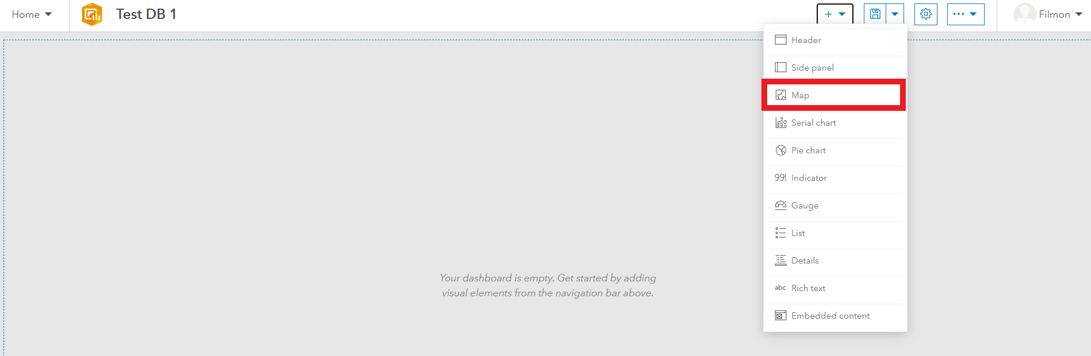

1. Once the map has been added, other elements can be used to display data from the map. Dashboard elements can be moved and sized appropriately.

**Adding a Dashboard to a Story Map**

1. In My Content under Create App select StoryMaps

2. Click on the plus sign beside Share Your Story and select embed. Paste a link to the dashboard which can be found at the bottom of the item page.

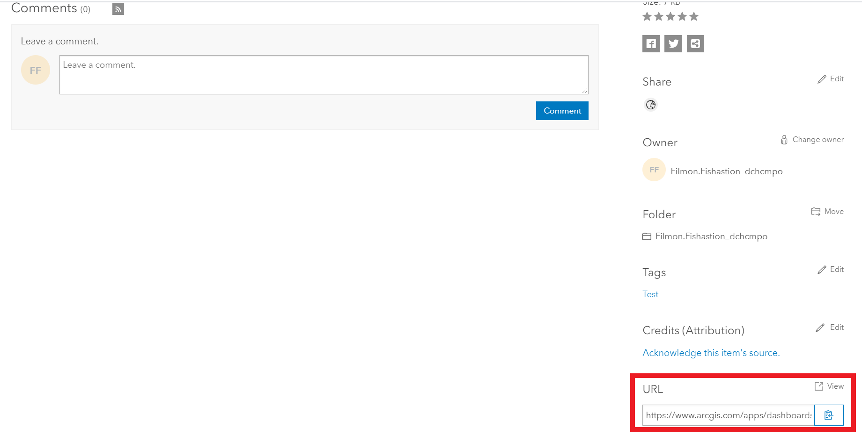

3. The dashboard should now appear on the StoryMap page. Hover the mouse over the map and a set of options will appear at the top. Select the first option (Display this content as a card). Then click on the gear within the same set of options to go to the settings and check the box that says Custom Card Details to input a different title/description than is already on the dashboard.